***Name:*** PRERNA VERMA

***Class:*** CSE-BD-01(A)

***UID:*** 19BCS3777

***AIM:*** Design a system that automatically turns on the light inside an Amirah whenever it is opened and turns off the lights after 100ms if there is enough light.

***APPARATUS:***

1. Breadboard
2. Arduino UNO
3. 2 Resistances
4. LED
5. Photo resistor
6. Few connecting wires

***CIRCUIT DIAGRAM:***

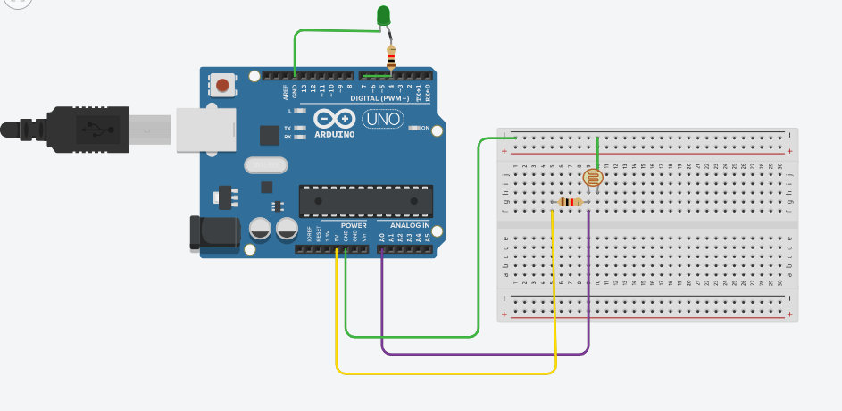

***THEORY:***

***CONCEPT USED:***

* The usage of Kirchhoff’s law:

1. Voltage

The total voltage in a loop is zero due to conservation of energy.

1. Current

The total current passing through a point across the junction is zero i.e., total current going is equal to total current coming.

* The LED is connected in series with the resistance so that current can be resisted.
* The Photo resistor must be connected to analog signal and a resistor so that we can read it on the serial Monitor and we can set as the needed.

***LEARNING & OBSERVATIONS:***

***PROBLEMS AND TROUBLESHOOTING:***

* To select the right port and type of Arduino.
* To check the connection as it might be loose.
* Check the components’ continuity with the help of multimeter.
* To check the coding (syntax, pin number etc.)

***PRECAUTIONS:***

* Handle the components carefully.
* Don not connect the Arduino till the circuit is completed which would cause Arduino voltage shock to individual.

***LEARNING OUTCOMES:***

* Connections in the breadboard are made in such a way that LED and resistor are in series.
* LED is connected with pin 7 of Arduino board.
* Voltage is maintained in the circuit 5ev.
* The n side of LED is connected to the ground and the resistance is connected to the positive terminal i.e., 5eV.
* In coding we have connected the LED with pin 7 of the board and in coding OUTPUT would be upon 7 only.
* We have checked all components using a multimeter by putting it on the speaker mode with would make a sound when the component is working or not.
* The Serial monitor syntax and usage is cleared.

***RESULT:*** We have design a system that automatically turns on the light inside an Amirah whenever it is opened and turns off the lights after 100ms if there is enough light.